Large bright, quiet and spacious condo in Newark ($1950)
Condominium in Newark on Cedar Blvd. and Stevenson Blvd.
Located in the Murieta Complex, 3 bedroom, 2 full bath, top floor
Rent includes:
Water, garbage, use of pool and gym, two parking spaces
Features:
Bright quiet 3rd floor condo in a well
maintained building with convenient elevator access
All carpeted with high 9 foot ceilings
New appliances (Stove, Dishwasher, Microwave, and Refrigerator)
Washer and dryer inside condo
Newly painted
Pool and gym access
Covered parking for one car
Two balconies (bedroom and living room)
Very safe location with secure access
Transportation:
Two blocks from I880 - Excellent access to bay area
Convenience:
Food 4 Less market and restaurants right across street. Walk to shopping.
Restrictions:
No pets except cats, No Smoking
Rent:
$1950 per month, $2200 deposit, one year lease
Contact:
Email to this ad or phone Alan at 831-466-9932
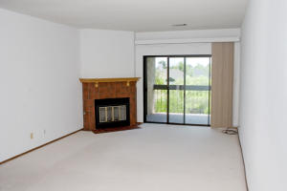 | 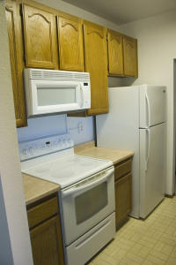
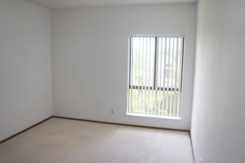 | 